Launch one ec2 instance using amazon linux 2.

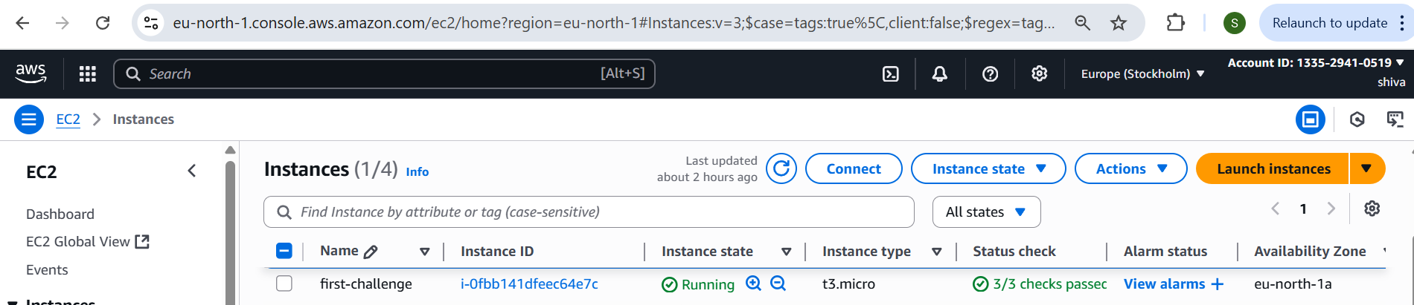

**Install Docker:**

install docker

sudo systemctl start docker

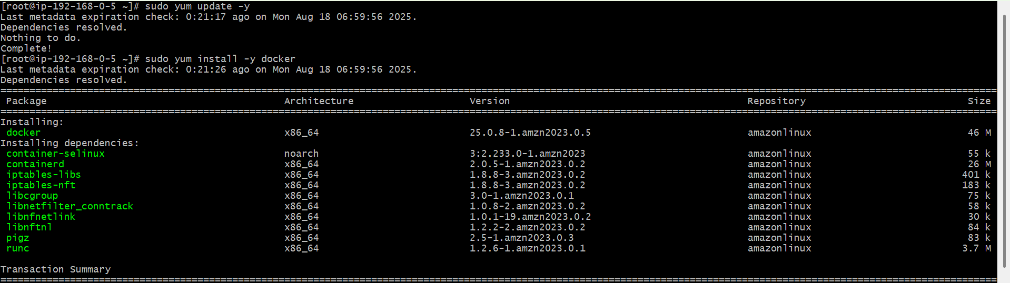

**Install jenkins**

Install java version 17

sudo apt install openjdk-17-jdk -y

java –version

Add Jenkins Repository

sudo wget -O /etc/yum.repos.d/jenkins.repo https://pkg.jenkins.io/redhat-stable/jenkins.repo

sudo rpm --import <https://pkg.jenkins.io/redhat-stable/jenkins.io.key>

install Jenkins

sudo yum install jenkins –y

sudo systemctl start Jenkins

open in web browser

http://<your-server-ip>:8080

copy password from below path

sudo cat /var/lib/jenkins/secrets/initialAdminPassword

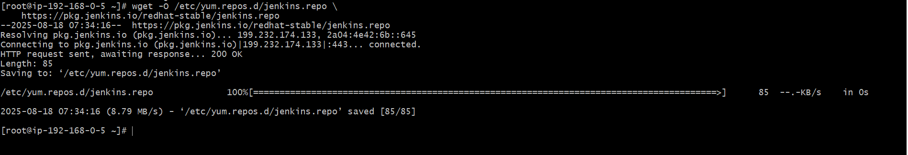

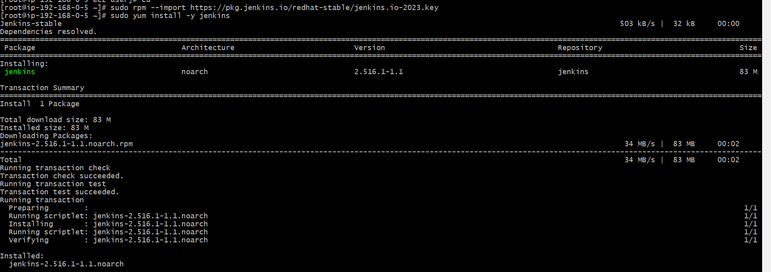

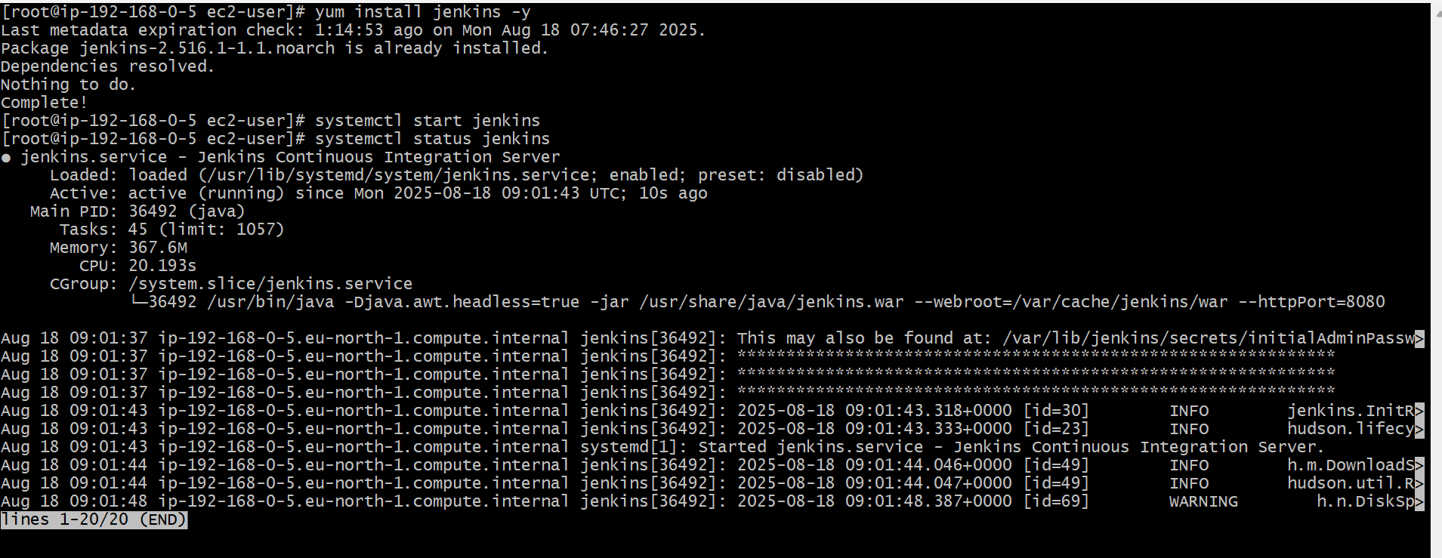

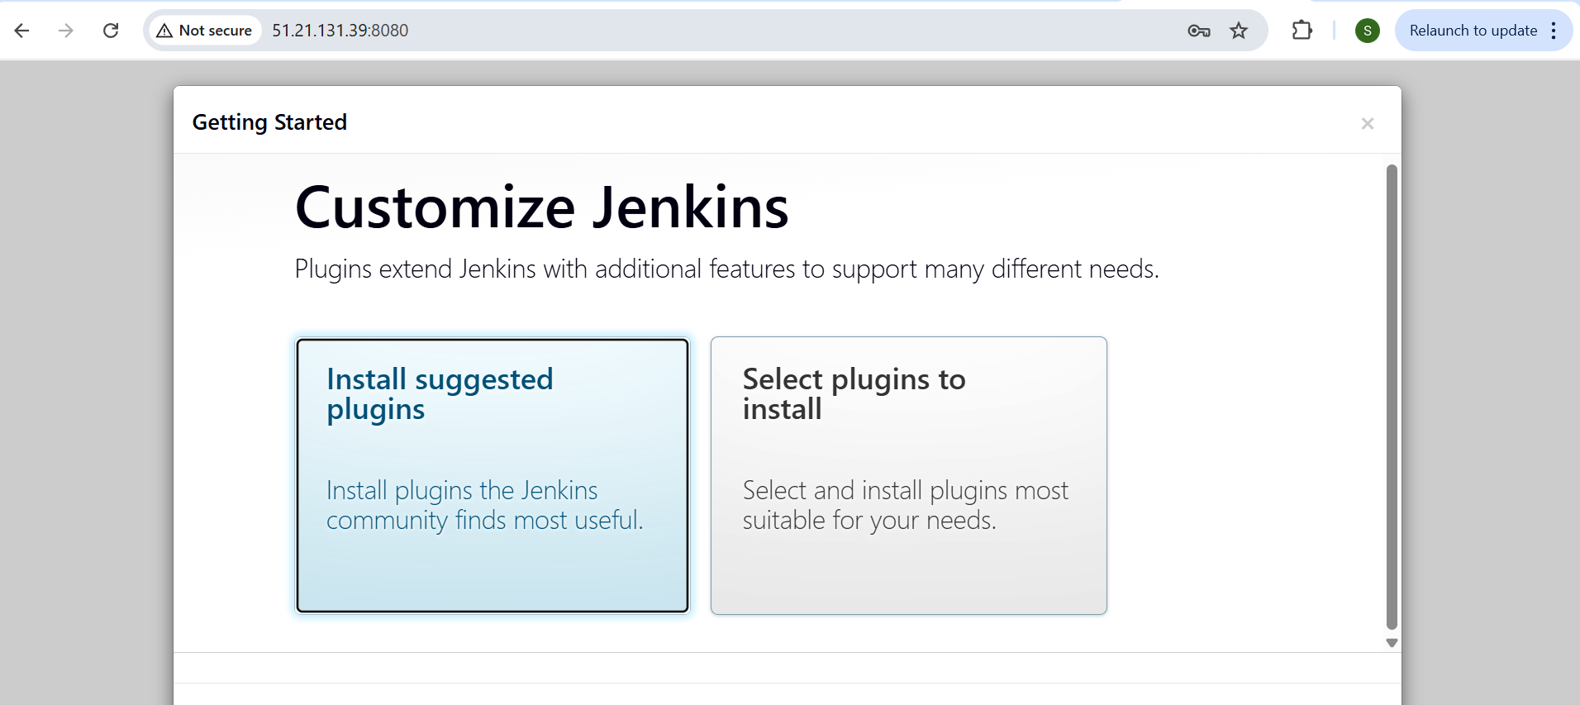

**Install apache :**

sudo yum install -y httpd

sudo systemctl start httpd

open browser and check with ip

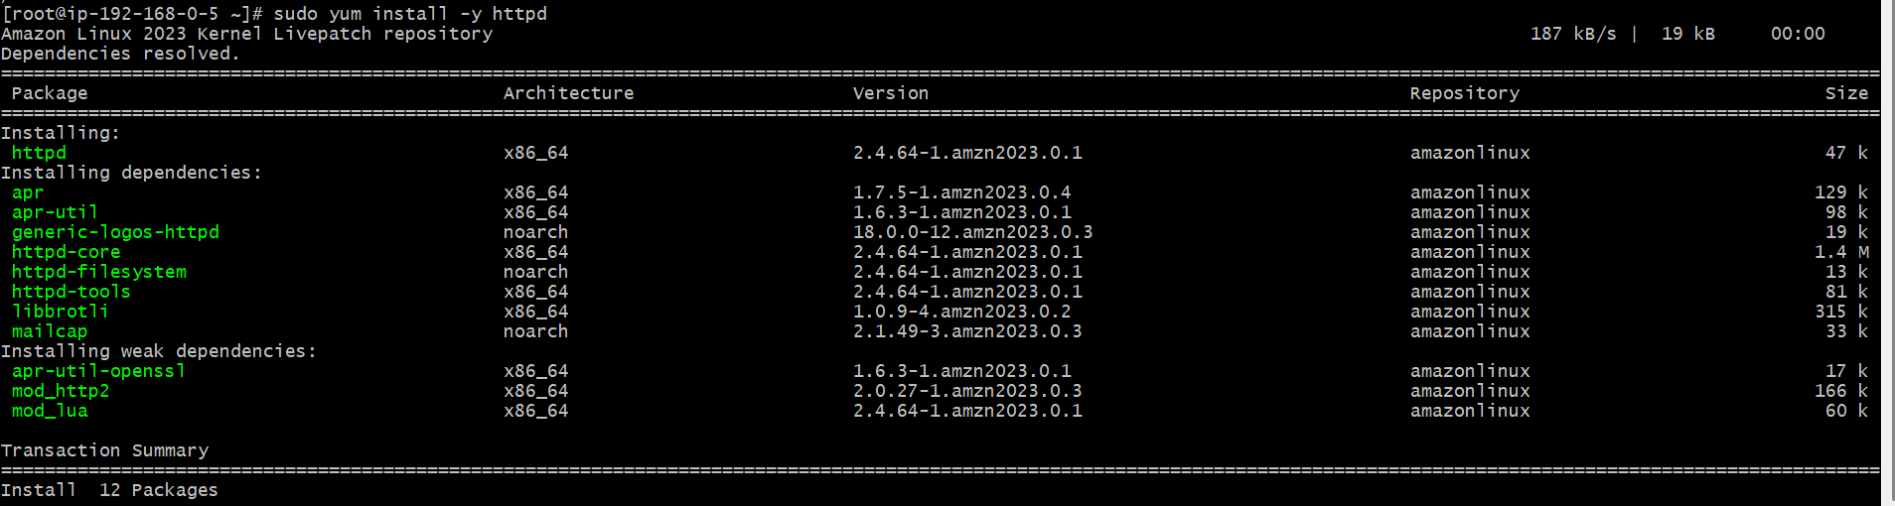

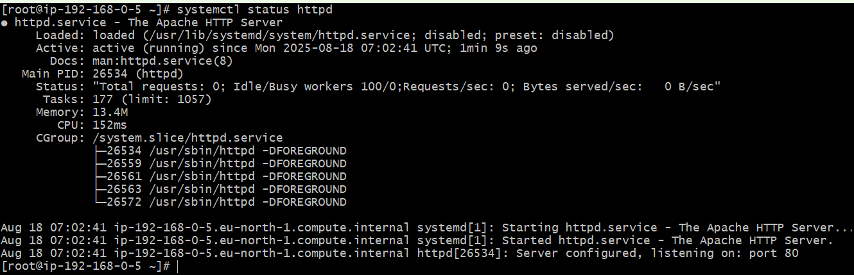

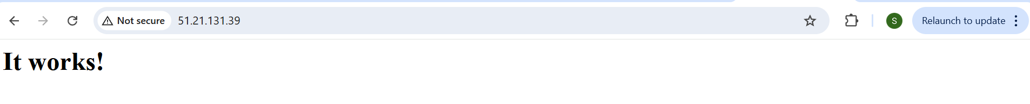

**Install nginx :**

**I**nstall nginx by using below command

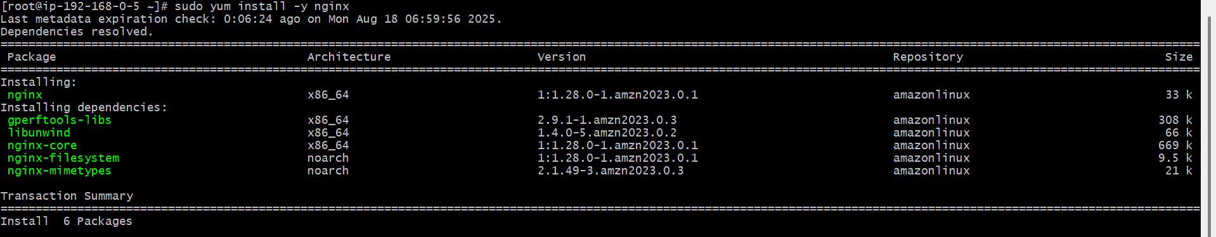

Start the nginx server using command

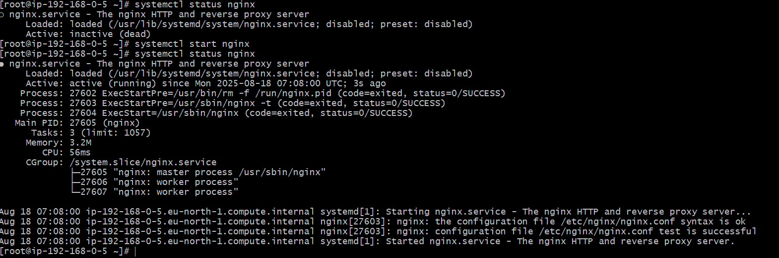

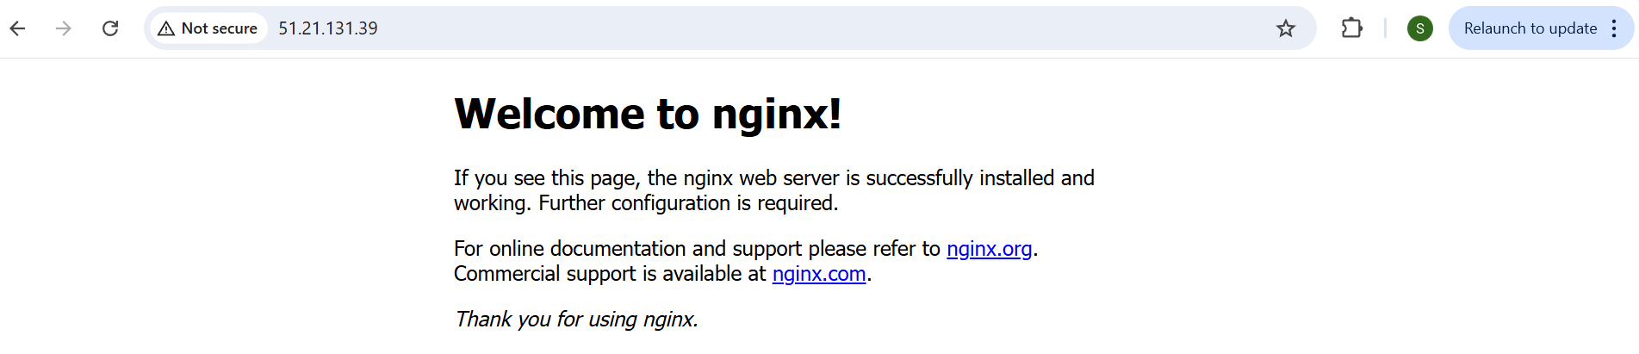

**Install Apache Tomcat:**

Go to /opt directory

Copy link of tar file

Wget tarfile link

Extract tar file

Cd tarfile

Cd bin – to start use startup.sh

